



P.O Box 71150, Nigeria
45 Oduduwa Way, GRA Ikeja, Lagos Nigeria.
Email:



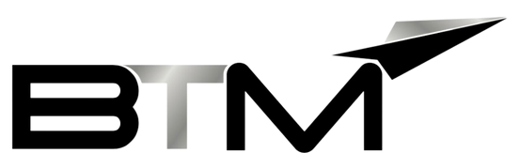
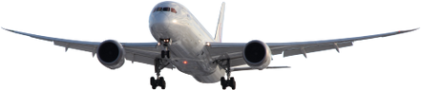
SALES SHEET

BUSINESS TRAVEL MANAGEMENT
CAR TRANSFER



01


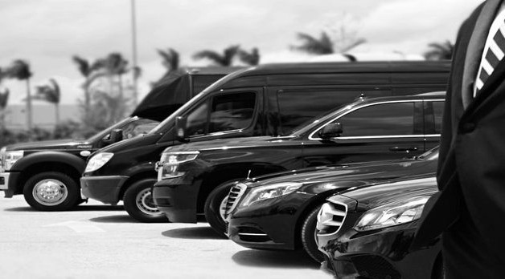
Airport transfers are pre-booked methods of transport for picking up travelers from an airport and dropping them off at their chosen destination, whether it be accommodation, cruise port, or another local point of interest, for a set price.

CAR TRANSFER

BTM has an extensive range of products and services, which may be specifically tailored to suit each individual client’s requirements. Included in our bouquet of services are the BTM Nigeria Airport car transfer services.

BTM is in partnership with notable internationally known and local suppliers reliable enough to provide globally acceptable car transfer service for our clients.
Our vehicle ranges from Sedan, SUV, Luxury SUVs, shuttle bus, secure escort, Limo services, etc. to the BTM worldwide network through our partners, this service can also be extended to travelers traveling to other BTM Partner countries.



BTM Nigeria airport transfers include options such as shared shuttles, private cars, and mini-busses, catering to a wide range of groups from small family holidays to large group getaways.
02




03

Standard Pricing Template:
Note: all fees are payable in Naira or USD.

ACTION

CAR TRANSFER

CAR TRANSFER

CAR TRANSFER
SERVICE DESCRIPTION

TRAVEL SERVICES FEATURES

Booking Charge

Booking Charge
CHARGES

$15.00/ ₦11,550

$30.00/ ₦23,100

SERVICE DESCRIPTION

Travel service

Car Hire Booking/Vehicle Transfer

Specialized Car Bookings







P.O Box 71150, Nigeria
45 Oduduwa Way, GRA Ikeja, Lagos Nigeria.
Email: bidresponse@btmlimited.net

BE MANAGED BY THE BEST.

